# SOP - Celery tasks failure rate

## Failure tasks dashboard

## Check failure tasks backtrace

## Kyuubi REST Docs

## If one task keeps failing

## How to create test sessions

## Failure tasks dashboard

Alert: total_celery_tasks_failure_rate

<https://console.sherlock.io/d/HfsLVeD7z/task-monitoring?orgId=1>

Check flower from link for failure tasks: <http://shepherd-api-adsshepherd.vip.ebay.com:5555/tasks?state=FAILURE>

If the failures are mainly from **task.metrics.tasks.spark_data_collection** or **task.metrics.tasks.data_collection** , please check the dashboard from <https://console.sherlock.io/d/OQV1a0pVz/data-collection-task?orgId=1>

If the failure rate in the dashboard increase a low. Then we need to check the task event log from [Rule level event log](https://console.sherlock.io/explore?orgId=1&left=%7B%22datasource%22:%22kvFT3BCMk%22,%22queries%22:%5B%7B%22expr%22:%22%7B_namespace_%3D%5C%22adsshepherd%5C%22,%20_schema_%3D%5C%22task%5C%22%7D%7C%20logfmt%22,%22refId%22:%22A%22,%22editorMode%22:%22code%22,%22queryType%22:%22range%22%7D%5D,%22range%22:%7B%22from%22:%22now-1h%22,%22to%22:%22now%22%7D%7D)

Check reason for failure

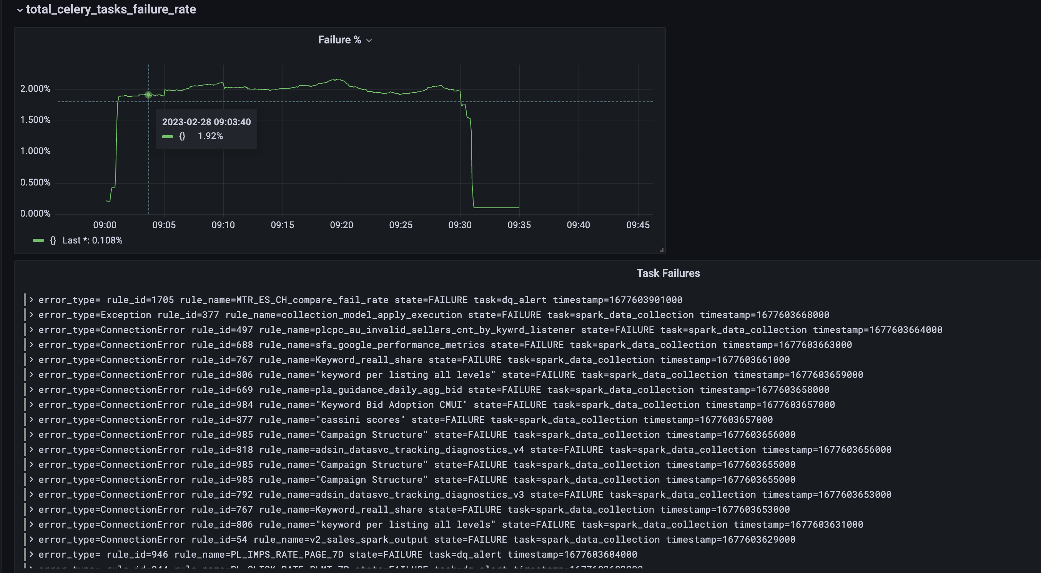

## Check failure tasks backtrace

If the failed tasks are all about ES client read timeout, please check this SOP: Celery task fail to write to Elasticsearch

If the failed tasks are spark job related, please check following steps.

**Note: Livy in control center will be expired from March 6, 2023 due to impersonation is disaled.**

## Kyuubi REST Docs

Link: <https://pages.github.corp.ebay.com/hadoop/kyuubi-docs/ebay_user_guide/index.html>

## If one task keeps failing

1. Find the failed task id
2. Find the log of this task from [ES log](https://esadsquality-kibanaslc.vip.ebay.com/app/discover#/?_g=(filters:!(),query:(language:kuery,query:%27%27),refreshInterval:(pause:!t,value:0),time:(from:now-1d,to:now))&_a=(columns:!(levelname,message),filters:!(),index:%272b636f30-9188-11ed-b225-af600d01e3a8%27,interval:m,query:(language:kuery,query:%27%27),sort:!())) (search with task_id.keyword: <task_id>) and fetch the session and statement request body.
3. Create test session and statement with the steps in below steps from tools like postman.
4. Spark application link can be composed with

https://apollo-rno-rm-1.vip.hadoop.ebay.com:50030/proxy/<engineId>  
engineId could be fetched when request GET session API ([http://<kyuubiInstance>/api/v1/sessions/<sessionId>](http://hadoopkyuubi-0.hadoopkyuubihl.hadoopmaster-ns.svc.116.tess.io:10011/api/v1/sessions/9057f0c0-7da5-4447-b505-52fc4bac0f4a))

1. Check the log of the Spark application. If no error found in the log, please continue with below steps.
2. Fetch the statement event ([http://<kyuubiInstance>/api/v1/operations/<statementId>/event](http://hadoopkyuubi-0.hadoopkyuubihl.hadoopmaster-ns.svc.116.tess.io:10011/api/v1/operations/99258dc6-c1e9-4ee7-9616-4f2dc88ce094/event)) to see if the statement has any error.
3. If you can't figure out the root cause from the error, please find out Shao, Bingcheng
4. Manual [Zeta](https://zeta.dss.vip.ebay.com/zeta/#/notebook) (also support kyuubi)run returns results

## How to create test sessions

This step helps create a test session which has a blank session name with Rest API <https://kyuubi.hadoop.vip.ebay.com/api/v1/sessions>

It is not managed by control center and can help to debug kyuubi issues.

All request need to call with _ADS_SRE basic authentication

POST request

URL: https://kyuubi.hadoop.vip.ebay.com/api/v1/sessions

Body {

"configs":{

"spark.yarn.queue":"hdlq-business-ads-data-high-mem",

"kyuubi.session.cluster":"apollorno",

"spark.binary.majorVersion": "2.3.1",

"hive.server2.proxy.user": "b_ads_data",

"kyuubi.session.name": "Ads_Shepherd_Shared_test_sql",

"kyuubi.operation.language": "sql",

"spark.jars": "viewfs://apollo-rno/user/b_pl/infra_udf/spark-udf-1.0-SNAPSHOT.jar",

"kyuubi.engine.share.level": "CONNECTION",

"spark.sql.crossJoin.enabled": true

}

}

Response

{

"identifier": "3754d430-a6e0-4f79-8a1a-0b2135a2737d",

"kyuubiInstance": "hadoopkyuubi-0.hadoopkyuubihl.hadoopmaster-ns.svc.116.tess.io:10011"

}

Please keep the kyuubiInstance as the host for the following requests

Delete request to delete the test session

DELETE request

URL: http://<kyuubiInstance>/api/v1/sessions/<sessionId>

Refer link: <https://pages.github.corp.ebay.com/hadoop/kyuubi-docs/ebay_user_guide/using_kyuubi_rest_api/submit_interactive_sql_pyspark_scala.html>